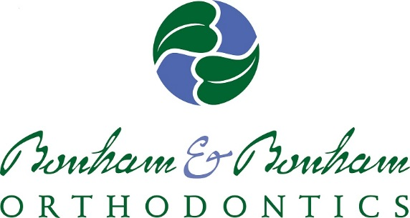

Bonham & Bonham Orthodontics is pleased to support a variety of educational and community organizations through sponsorship advertising. To submit an advertising request, please complete the bottom section of this form and e-mail it to info@mauibraceplace.com.

PLEASE ALLOW 2 WEEKS FOR A RESPONSE
GUIDELINES:
1. All requests require a completed application (below).
2. Due to the overwhelming sponsorship and advertising requests we receive, first priority will be given to patients who are currently in orthodontic treatment
3. While we are pleased to sponsor your organization, we ask for your understanding that it is not possible to approve all requests which are received. As with any business, we have an advertising budget that dictates how much we can annually spend.
___________________________________________________________________
SPONSORSHIP APPLICATION

Date: _____________________I have read the guidelines above: ⃝ Yes ⃝ No

Patient Name: _____________________________________________Phone: ______________________________

Email:________________________________________________________________________________________

Patient Address:________________________________________________________________________________

Patient Treatment Status:________________________________________________________________________

Organization to be sponsored:____________________________________________________________________

Cost of sponsorship:_____________________________________________________________________________

What does this cost include:______________________________________________________________________

Size of ad:_____________________________________________________________________________________

Due Date:______________________ Check Payable to:________________________________________________

Send check to:_________________________________________________________________________________

Send artwork to:_______________________________________________________________________________

***PLEASE ATTACH ANY OTHER PERTINENT INFORMATION ALONG WITH THIS FORM***
Email completed form to info@mauibraceplace.com

